** ICT Technician**

**Salary: Single Status Grade 6 £20,853 - £21,695**

**Full time permanent post**

Required as soon as possible

**INFORMATION FOR APPLICANTS**

**CONTENTS**

1. Letter from Headteacher
2. Job Description
3. Person Specification

June 2022

Dear Applicant

**ICT Technician**

Thank you for your interest in this post.

We are St Catherine’s College – preparing students to stand shoulder to shoulder with their peers, locally, nationally, and globally.

We are proud of our college, our talented and highly motivated staff and students. Our staff team work tirelessly to ensure that teaching is the best it can be, and everyone has a role to play in this. We support each other and there is an open, friendly, and collegiate atmosphere where new members of the team are welcomed and supported.

We are:

* An Investors in People Award School, which means that we invest heavily and value the development of all our staff
* An inclusive Church of England School with the benefits of links with The Diocese of Chichester and the opportunity to promote strong lasting values based on the Christian faith

Understandably this letter and our website only gives a flavour of the college. We therefore encourage visits for prospective candidates to see our college in action. We do understand however that visits are not always possible or practical and you would not be at a disadvantage if you are unable to visit the college.

**The Post**

We are looking to recruit a Technician who will provide IT support for both the curriculum and the administrative users throughout the College. The post holder will support the IT Manager with the development of the IT infrastructure and cloud resources available in the College.

Main tasks will include:

* Supporting St John’s Meads C of E Primary School IT systems
* Managing the IT ticket system
* Supporting the filtering system, Wi-Fi, CCTV and our VoIP telephone system
* Support teaching and learning by providing an on-call service to teaching staff throughout the day
* To maintain the College’s asset register
* To support Office 365 throughout the college

The successful applicant will have previous experience of working in an IT role in the public or private sector. It is not necessary to have previously worked in a school environment.

**We offer you**

**We know it’s a competitive market and are proud of what we can offer:**

* **Excellent career development opportunities**



* **A geographical location**, being situated near Sovereign Harbour, Eastbourne’s award-winning Marina. It is part of several miles of beautiful coastline, including the South Downs National Park, the white cliffs of Beachy Head and 1066 country
* **A friendly**, supportive and caring staff team
* **CPD,** starts immediately upon employment
* **A fabulous staff room** with complimentary tea and coffee
* **A café** that serves at breakfast, break and lunch using freshly sourced ingredients
* **Local Government Pension Scheme**
* **Free Flu Vaccine**
* **Highly visible** supportive senior leaders
* **Great Students** – you can make a massive difference to them
* Did you know that buying a house in East Sussex can be cheaper than in many other counties in the UK.
* We are part of a growing trust, (Diocese of Chichester Academy Trust)

**Your Application**

Completed application forms and letters of application should be sent directly to the college addressed to Mrs S Windsor, Head of Personnel, swindsor@stcatherines.college and arrive by no later than **noon on Monday 13 June 2022**.

Please use the standard application form, accompanied by a letter of application, which must be no more than two sides of A4. We are unable to consider CVs in place of application forms unless you are a person with a disability and a CV is the most convenient method of applying. In your letter of application, you should clearly address the relevant sections of the Person Specification for this post and may find it helpful to use headings.

We are committed to safeguarding and promoting the welfare of children and young people, successful applicants will need to undertake a DBS enhanced clearance.

I am conscious of the time and effort it takes to apply and am grateful for your interest. Shortlisted candidates should hear from us shortly after the closing date.

St Catherine’s is a thriving college with a bright future and a vibrant and collegiate atmosphere within which to work. I am keen that we appoint quality candidates to join what is, I believe, one of the best staff teams. If I can be of any assistance or provide any further information, please do not hesitate to contact me.

Yours faithfully



Solomon Berhane

Headteacher

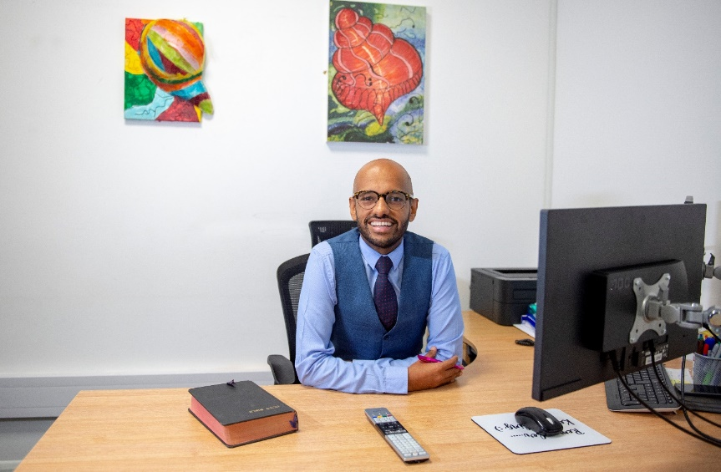

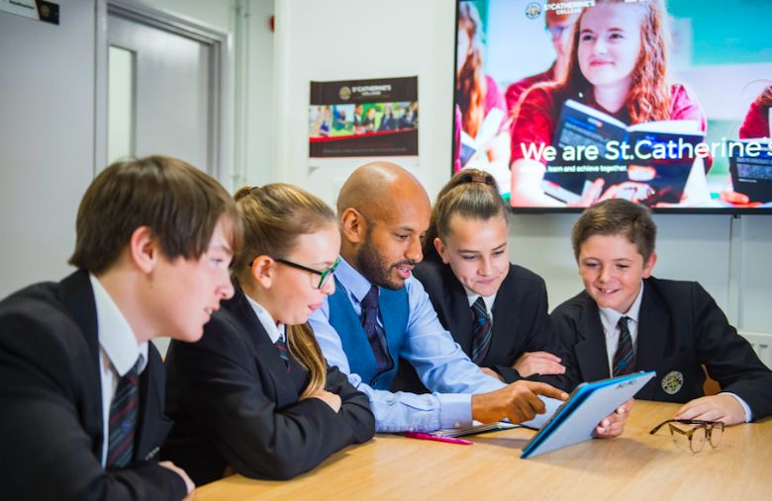

**

**Job Description**

Post: IT Technician

Responsible to: IT Manager

Grade: Single Status Grade 6

Hours: 37 hours per week 52 weeks per year

**Main Purpose**

To provide IT support for both the curriculum and the administrative users throughout the College and St John’s Meads Primary.

To support the IT Manager with the development of the IT infrastructure and cloud resources available in the College.

**Main Tasks**

To Support the IT Manager with the following:

1. Office 365.
2. The college’s Wi-Fi and filtering system.
3. The network infrastructure.
4. To support teaching and learning by managing the College’s ticket system and providing an on-call service to teaching staff throughout the day.
5. To assist the IT Manager with purchasing software and hardware for the College.
6. To provide technical assistance for out of hours school events
7. To maintain the College’s VoIP telephone system and mobiles.
8. To maintain the CCTV system.
9. To maintain the asset register.
10. To support the examinations department with IT technical support and set up.
11. To maintain the off-site PC’s, internet, and phone system within our Motor Vehicle garage.
12. To install and maintain network cabling.
13. To install and maintain software within the College.

This job description sets out the duties of the post at the time it was drawn up. The post holder may be required, from time to time, to undertake other duties within the college as may be reasonably expected, without changing the general character of the duties or the level of responsibility entailed. This is a common occurrence and would not justify a reconsideration of the grading of the post.

**PERSON SPECIFICATION: ICT TECHNICIAN**

|  |  |  |  |
| --- | --- | --- | --- |
| **Attributes** | **Essential** | Desirable | |
| Qualifications and training | * Good general education, with GCSE’s or equivalent in English and Maths | * Suitable ICT qualifications | |
| Experience | 🖹 Experience of working in an IT role in the public or private sector |  | |
| Skills and Abilities | * Hardworking * Ability to work with tact and diplomacy and maintain confidentiality * 🗣 Good communication skills   ✍ Able to manage time effectively and work to deadlines  ✍🗣Be reflective and proactive in seeking feedback to constantly improve practice  ✍🗣Initiative and ability to work without direct supervision, taking responsibility for tasks, prioritising and scheduling your own work | * Experience of working with Office 365 | |
| Knowledge and Understanding | * Understanding of the fundamentals of IT for IT infrastructure | 🖹Knowledge of software profiles such as: Active Directory, Microsoft Office 365. Follow-me-printing or similar systems. SharePoint.  Network fundamentals | |
| Values | * 🗣 Be broadly in sympathy with the aims and ethos of the School * A commitment to comprehensive education, equal opportunities and inclusion |  |
| Personal Qualities | ✍🗣 Approachable   * Excellent attendance record   ✍🗣High expectations of self and others   * Resilient, motivated and committed to achieving excellence * Is self-motivated and hard working * Possesses a sense of humour and the humility to admit mistakes * Shows imagination, vision and proactivity * Possesses an infectious enthusiasm, stamina, and considerable energy * Ability to work under pressure to achieve, to have high expectations, lead by example and meet deadlines * Identify and undertake personal development opportunities and suggest personal development targets |  |

**Criterion assessed by:** 🖹 = application form; ✍ = letter of application; 🗣 = interview

