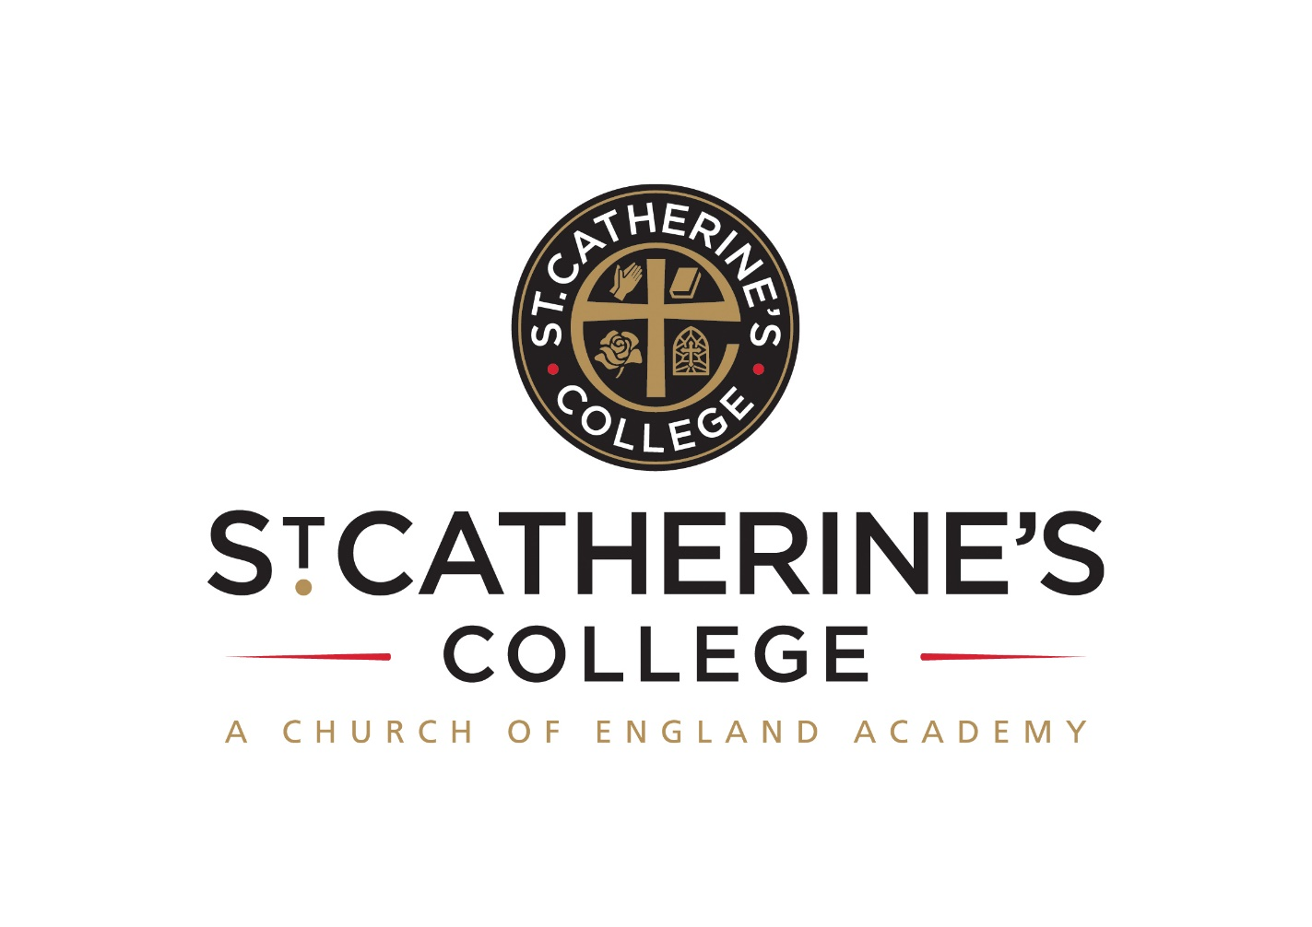 **TEACHER OF HISTORY**

**Salary: TMS / UPS**

Required January 2023

Permanent full-time post

Please note that we reserve the right to consider applications as they arrive

**INFORMATION FOR APPLICANTS**

**CONTENTS**

1. Letter from Headteacher
2. Person Specification

October 2022

Dear Applicant

**Teacher of History**

Thank you for your interest in this post.

We are St Catherine’s College – preparing students to stand shoulder to shoulder with their peers, locally, nationally, and globally. At St Catherine’s College people matter, results count, and we have a passion for excellence.

We are proud of our college, our talented and highly motivated staff, and students. Our staff team work tirelessly to ensure that teaching is the best it can be, and everyone has a role to play in this. We support each other and there is an open, friendly, and collegiate atmosphere where new members of the team are welcomed and supported.

We are:

* An inclusive Church of England School with the benefits of links with The Diocese of Chichester and the opportunity to promote strong lasting values based on the Christian faith

Understandably this letter and our website only gives a flavour of the college. We therefore encourage visits for prospective candidates to see our college in action. We do understand however that visits are not always possible or practical and you would not be at a disadvantage if you are unable to visit the college.

**The Post**

We are looking to recruit an exceptional Teacher of History, either an experienced teacher or an ambitious NQT.

This is a permanent full time post to start on 1 January 2023.

You will have the ability to inspire young people, instilling a love of History both as an academic subject and applying it to the world around them. You will be a tireless advocate for your subject.

Our History Department teach Pearson / Ed Excel and cover:

Crime and Punishment

Weimar and Nazi Germany

Superpower Relations

Henry and his ministers

Our Head of History will be rewriting the curriculum over the next two years, and this is an exciting opportunity to be involved with shaping a new and exciting History curriculum.

The History Department are members of the Historical Association and run school trips to Belgium and Berlin every year.

**We offer you**

**We know it’s a competitive market and are proud of what we can offer:**

* Excellent career development opportunities

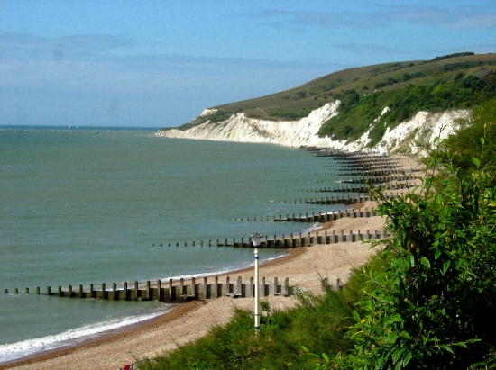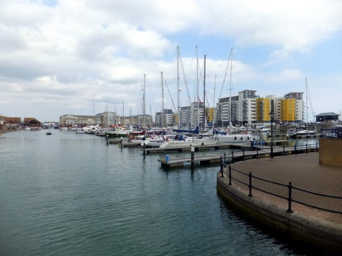

* A geographical location, being situated near Sovereign Harbour, Eastbourne’s award-winning Marina. It is part of several miles of beautiful coastline, including the South Downs National Park, the white cliffs of Beachy Head and 1066 country
* A friendly, supportive, and caring staff team
* CPD, starts immediately upon employment
* A fabulous staff room with complimentary tea and coffee
* A café that serves at breakfast, break and lunch using freshly sourced ingredients
* Teachers’ Pension Scheme
* Free Flu Vaccine
* Highly visible supportive senior leaders
* Great students – you can make a massive difference to them
* St Catherine’s College is a Diocese of Chichester Academy Trust Academy
* Did you know that house prices in East Sussex are competitive in comparison to some other parts of the country?

**Your Application**

Completed application forms and letters of application should be sent directly to the college addressed to Mrs S Windsor, Head of Personnel, [SWindsor@stcatherines.college](mailto:SWindsor@stcatherines.college). The closing date for this post is 12 noon on Tuesday 18 October. Please note that we reserve the right to consider applications as they arrive.

Please use the standard application form, accompanied by a letter of application, which must be no more than two sides of A4. We are unable to consider CVs in place of application forms unless you are a person with a disability and a CV is the most convenient method of applying. In your letter of application, you should clearly address the relevant sections of the Person Specification for this post and may find it helpful to use headings. We are committed to safeguarding and promoting the welfare of children and young people, successful applicants will need to undertake a DBS enhanced clearance.

I am conscious of the time and effort it takes to apply and am grateful for your interest.

Please note that applications will be considered as they arrive, and the College reserves the right to make an appointment immediately. St Catherine’s is a thriving college with a bright future and a vibrant and collegiate atmosphere within which to work. I am keen that we appoint quality candidates to join what is, I believe, one of the best staff teams. If I can be of any assistance or provide any further information, please do not hesitate to contact me.

Yours faithfully



Soloman Berhane

Headteacher

**PERSON SPECIFICATION: TEACHER OF HISTORY**

|  |  |  |  |
| --- | --- | --- | --- |
| **Attributes** | **Essential** | Desirable | |
| Qualifications and training | * Qualified teacher status recognised by the DfES * Graduate with a degree in History or a related subject |  | |
| Experience | 🖹 A successful classroom practitioner who can teach History at KS3 and KS4 |  | |
| Skills and Abilities | * Be a talented classroom practitioner, with potential to develop further * 🗣Able to teach History across the age and ability range * Enthuse pupils for History * Will teach a vibrant and varied culture of History * Will utilise appropriate technologies in the classroom to ensure that learning is current, relevant and enjoyable * 🗣Possess good ICT skills and be able to use them in their own teaching * 🗣 Able to communicate well, both in writing and orally   ✍🗣 Set goals that stretch and challenge pupils of all backgrounds and abilities  ✍🗣 Ensure your planning identifies and caters for students of different backgrounds and needs, specifically pupil premium pupils, those with special educational needs and the more able  ✍ Ensure the effective and efficient deployment of classroom support  ✍Ensure your planning provides appropriate and timely coverage of all aspects of the curriculum and that students acquire and consolidate the knowledge, skills and understanding expected  ✍Use relevant data to establish high expectations, monitor progress and plan sequences of lessons that respond to students learning and ongoing progress  ✍Provide regular formative feedback to students, both written and oral, that encourages them to respond and enables them to understand how to progress  ✍ Able to manage time effectively and work to deadlines |  | |
| Knowledge and Understanding | * 🗣Understanding of the principles, processes and strategies underpinning outstanding teaching and learning * 🗣 Outstanding knowledge of current educational developments/issues in History teaching   ✍ Have excellent subject knowledge and a passion to teach |  | |
| Values | * 🗣 Be broadly in sympathy with the aims and ethos of the College * A commitment to comprehensive education, equal opportunities and inclusion * A passionate commitment to achieving the highest standards for all learners * A commitment to teaching approaches which make learning interesting, challenging, relevant and effective * An enthusiasm for running and involvement in, extra-curricular activities | * 🗣 A practising Christian |
| Personal Qualities | * Shows warmth, care and a sensitivity to the needs of others * Is self-motivated and hard working * Possesses a sense of humour and the humility to admit mistakes * Shows imagination, vision and proactivity * Possesses an infectious enthusiasm, stamina and considerable energy * Ability to work under pressure to achieve, to have high expectations, lead by example and meet deadlines | 🖹 Has a good health and attendance record |

**Criterion assessed by:** 🖹 = application form; ✍ = letter of application; 🗣 = interview

