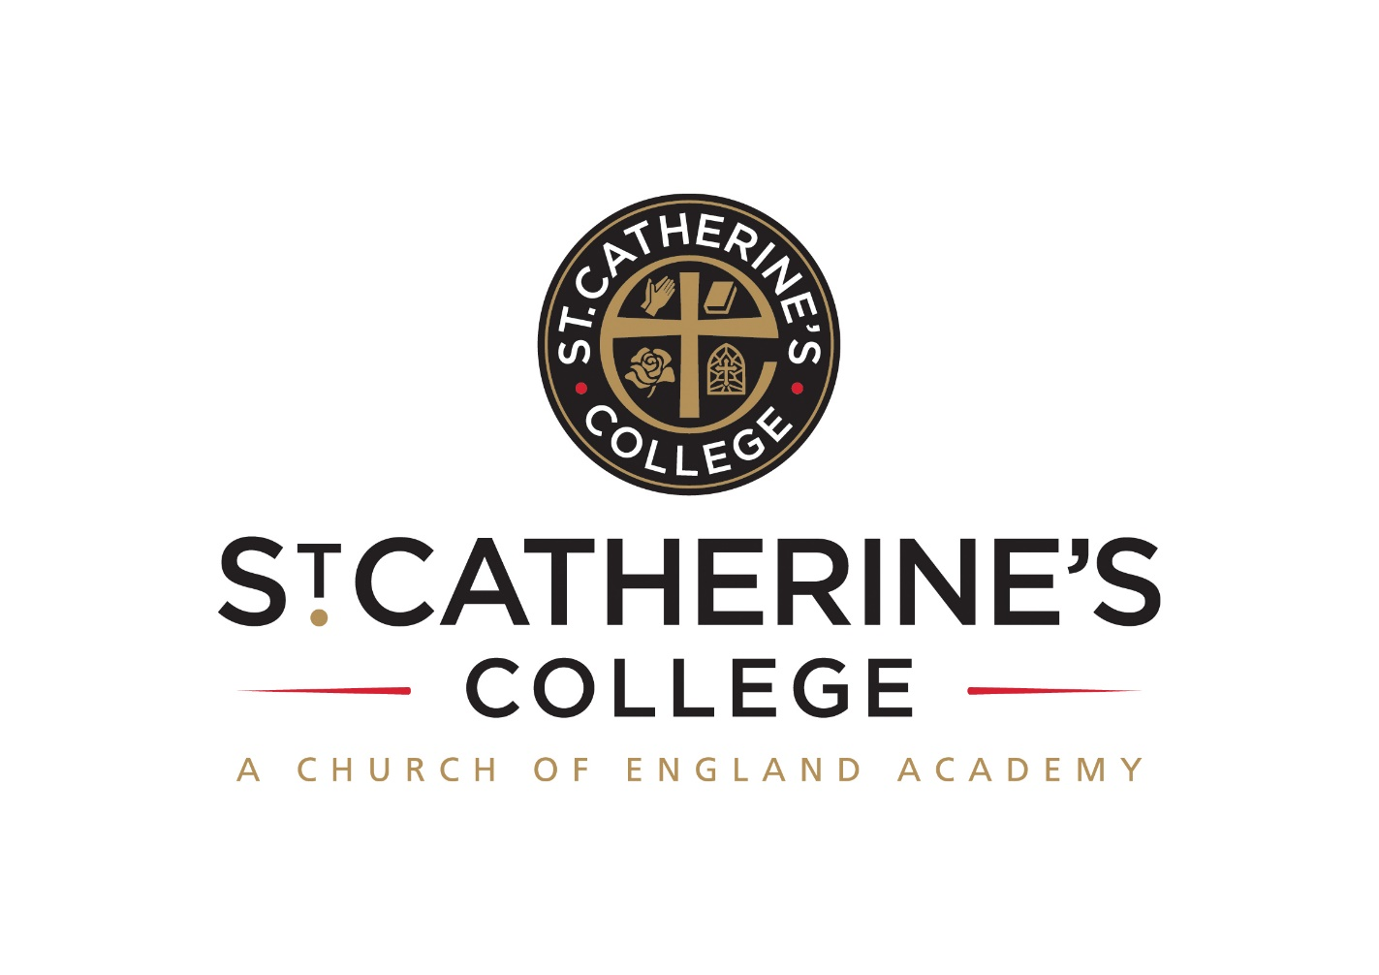**SCIENCE TECHNICIAN**

**Salary Single Status Grade 4: £19,264 - £19,650 pa pro rata**

17.5 hours per week term time only

Hours to be worked over 5 days 11.00 – 14.30

Required Immediately

**INFORMATION FOR APPLICANTS**

**CONTENTS**

1. Letter from Headteacher
2. Job Description
3. Person Specification

May 2022

Dear Applicant

**Science Technician**

Thank you for your interest in this post. I hope that you find the enclosed information useful and that you are motivated to join our college at a very exciting time.

We are St Catherine’s College – preparing students to stand shoulder to shoulder with their peers, locally, nationally, and globally. At St Catherine’s College people matter, results count, and we have a passion for excellence.

We are proud of our college, our talented and highly motivated staff, and students. Our staff team work tirelessly to ensure that teaching is the best it can be, and everyone has a role to play in this. We support each other and there is an open, friendly, and collegiate atmosphere where new members of the team are welcomed and supported.

We are

* An Investors in People Award School, which means that we invest heavily and value the development of all our staff.
* An inclusive Church of England School with the benefits of links with The Diocese of Chichester and the opportunity to promote strong lasting values based on the Christian faith.

Understandably this letter and our website only gives a flavour of the college. We therefore encourage visits for prospective candidates to see our college in action. We do understand however that visits are not always possible or practical and you would not be at a disadvantage if you are unable to visit the college.

**The Post**

We are looking for an enthusiastic person to join our busy Science Department as soon as possible. You should be organised and methodical in your approach to work, willing to undertake training as necessary and possess an ability to communicate well with both young people and adults.

**Full training will be given to the successful applicant, previous experience is not necessary.**

This is a part time post for 17.5 hours per week term time only.

**We offer you**

**We know it’s a competitive market and are proud of what we can offer:**

* Excellent career development opportunities

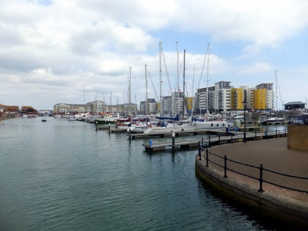

* A geographical location, being situated near Sovereign Harbour, Eastbourne’s award-winning Marina. It is part of several miles of beautiful coastline, including the South Downs National Park, the white cliffs of Beachy Head and 1066 country
* A friendly, supportive and caring staff team
* CPD, starts immediately upon employment
* A fabulous staff room with complimentary tea and coffee
* A café that serves at breakfast, break and lunch using freshly sourced ingredients
* Local Government Pension Scheme
* Free Flu Vaccine
* Highly visible supportive senior leaders
* Great students – you can make a massive difference to them

**Your application**

Completed application forms and letters of application should be sent directly to the college addressed to Mrs S Windsor, Head of Personnel, swindsor@stcatherines.college, and arrive by no later than **noon on Wednesday 8 June 2022.**

Please use the standard application form, accompanied by a letter of application, which must be no more than two sides of A4. We are unable to consider CVs in place of application forms unless you are a person with a disability and a CV is the most convenient method of applying. In your letter of application, you should clearly address the relevant sections (labelled ‘✍’) of the Person Specification for this post and may find it helpful to use headings.

We are committed to safeguarding and promoting the welfare of children and young people, successful applicants will need to undertake a DBS enhanced clearance.

I am conscious of the time and effort it takes to apply and am grateful for your interest. Shortlisted candidates should hear from us shortly after the closing date. We will be interviewing for this post the following week. St Catherine’s is a college with a bright future and a good atmosphere within which to work.

I am keen that we appoint quality candidates to join what is, I believe, one of the best staff teams in any school. If I can be of any assistance or provide any further information, please do not hesitate to contact me.

Yours faithfully



Solomon Berhane

Headteacher

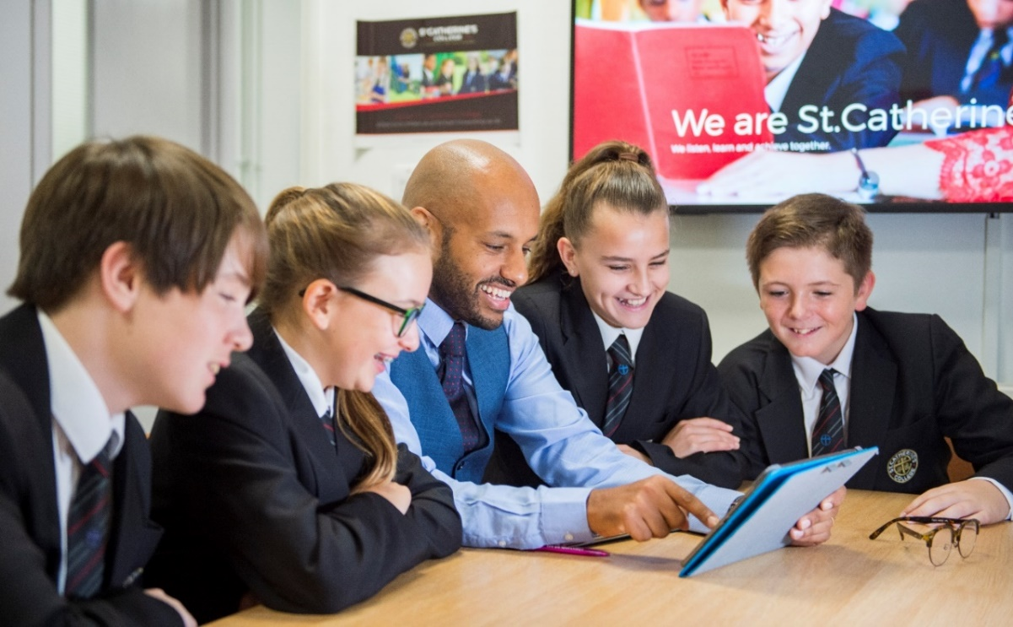

**Job Description**

**Post: Science Technician**

**Grade: Single Status Scale 4**

**Responsible to: Senior Science Technician**

**Main Purpose of the Job**

To provide technician support to the Science Department

**Mains tasks and responsibilities**

1. Prepare and assemble teaching resources, apparatus, materials, and equipment for use by staff and pupils in practical lessons and demonstrations
2. Prepare chemicals and solutions for school use following safe practice and storage in line with current regulations.
3. Daily set out equipment and resources in preparation for lessons
4. Deliver and collect lesson equipment from science labs
5. Cleaning and clearing away materials and resources after lessons as required.
6. Ensure the laboratory environments are suitable maintained and safe by fortnightly safety checks. Identify potential problems and report to Senior Science Technician
7. Maintain and undertake basic repairs and annual checks to equipment where practical and safe to do so.
8. First Aid – be a qualified first aider, providing first aid to the Science Department and being on the first aid rota.
9. Assist in the annual stocktake, cleaning and tidying of the chemical store.
10. To be confident in dealing with general enquiries from pupils and staff
11. Maintain a tidy, safe and operational prep room.
12. Assist the Senior Science Technician in the preparation of new resources as and when required
13. Be responsible for the safe storage of equipment and chemicals, including radioactive resources.
14. To provide consistent and effective support in line with requirements and responsibilities of your role
15. To take part in training activities to further your knowledge and skills
16. To abide by and work towards all the policies within the school e.g. Health & Safety, Equal Opportunities.
17. To undertake such other reasonable duties as may be required within the College.

**PERSON SPECIFICATION: SCIENCE TECHNICIAN**

|  |  |  |
| --- | --- | --- |
| **Attributes** | **Essential** | **Desirable** |
| Qualifications and training: | 🗎Good standard of general education |  |
| Knowledge, Understanding &  Experience: |  | 🗎Any relevant experience of working with children and young people  🗎🖂Experience of working in a college or school environment  🗎🖂General knowledge of Science |
| Skills and Abilities: | 🗎🖂Ability to work on own initiative  🗎🖂Ability to work under pressure  🗎🖂Ability to carry out instructions precisely  🗎🖂Ability to work effectively and supportively as a member of the school team  🗎🖂Ability to prioritise workload  🗎🖂Ability to demonstrate developed interpersonal and communication skills  🗎🖂🗣Ability to present a professional school image  🗎🖂An ability to communicate well with people of all ages. | 🗎 A willingness to learn new skills |
| Personal Qualities: | 🗎🖂Excellent organisational skills, prioritise, plan and organise one’s own time effectively  🗎🖂Enthusiastic, positive and energetic to be able to cope with the physical demands of an extremely busy department.  🗎🖂Ability to work under pressure  🗎🖂To have keen attention to detail  🗎🖂Ability to demonstrate initiative  🖂A commitment to equal opportunities, inclusion and comprehensive education  🗎Willingness to participate in further training and developmental opportunities  🖂🗣Ability to maintain confidentiality on all school matters  🗎🖂Good health and attendance record | 🗎🖂Interest in Science |

**Criterion assessment by:** 🗎 = application form; 🖂 = letter of application; 🗣 = interview; 🗹 = observation